Leah Elkins

Student ID: 008983922

D191 Advanced Data Management

Performance Assessment

December 17, 2022

Business Report

**Introduction**

This business report involves using a provided DVD Database and answering a real-world business question. I chose to revolve the business question around customers renting from the DVD store. In this report, I will use SQL tables, functions, procedures, and triggers to create a data set to answer the question: How can we keep our loyal customers returning to our business?

**A1. Data Description**

The data I will use for this report will involve the information about the customer and the customer’s rental history with the business. This will provide data about which customers return the most therefore telling us who our loyal customers are. I used data for my report from the provided DVD Database. The database includes the following tables:

* Category – the category data of the films
* film_category – the relationship between category and films
* film – the film title, decription, rating, length, release date, etc.
* actor – the actor’s first name, last name, and last update
* film_actor – the relationship between film and actor
* language – the language of the film
* inventory – the inventory data including store_id and film_id
* rental – the rental data including rental date, return date, etc.
* payment – the customer’s payments including amount and date
* staff – the staff data including first name, last name, email, etc.
* store – the store data including manager_staff_id and address_id
* customer – the customer data including first name, last name, email, active status, etc.
* address – the address data for staff, customers, and store
* city – the city names
* country – the country names

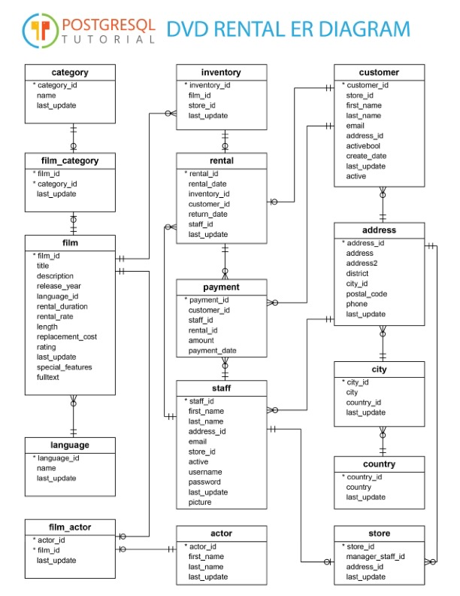

DVD Rental ER Diagram (PostgreSQL Tutorial)

# A2. Identifying Specific Tables

I specifically used the customer table and rental table for the detailed and summary sections for my report. These tables will give us information about the customers that rent from our business and how often they return. It will aid in narrowing down which customers return the most.

SQL Code that creates the detailed table

SQL code that creates the summary table

**A3. Identifying Specific Fields**

I specifically used fields from the customer table and rental table for the detailed and summary sections of my report.

The fields I used in the detailed section include:

* rental_id
* rental_date
* return_date
* staff_id
* customer_id
* first_name
* last_name
* email

The fields I used in the summary section include:

* customer_name
* email
* customer_amount

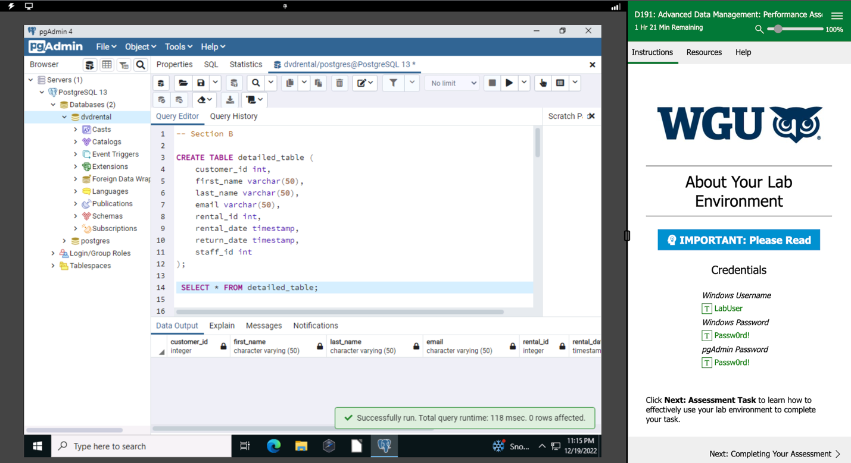

SQL code to show columns in the detailed table

SQL code to show columns in the summary table

SQL code inserting data into the detailed_table

**A4. Field Transformation**

I used first_name and last_name in the customer table from the detailed section to combine them to create a full name of the customer called customer_name in the summary section. Transforming these fields and combining them to create a full name for the customer will increase readability for the customer name field.

SQL code that shows the update_summary_function() transformation

SQL code that creates a trigger called update_summary_table

**A5. Business Uses**

The detailed and summary section both have different business uses. In the detailed section of the report, rental and customer information are included. This aids in business use by including the rental history of the customers. It tells us which customers frequent our business the most by keeping track of the DVD rentals within the business and which customers are included in these rentals. In the summary section of the report, customer name, email, and customer amount are included. This tells us who the customer is and keeps a count of how often they have rented from our business. We can use this information as a business to track these customers and award them for staying loyal to our business. For example, at the end of each month we could refresh our report and find out the top 10 customers that have rented from us for the month. We can award these customers with a coupon or a movie gift basket. This will give customers an incentive to continue to rent from us and new customers an incentive to start frequenting our business more.

**A6. Report Freshness**

To remain relevant to stakeholders, my report should be refreshed at the end of each month. This is to analyze all sales made in the month and keeps data updated. This provides us an overview of our sales and which customers are continuing to rent from us.

**F1: Data Freshness**

The stored procedure should run at the end of each month to ensure data freshness. The stored procedure was created to be used to refresh data in the detailed and summary tables of the report. The stored procedure I created is called update_report() and should be ran on a schedule to ensure data freshness. It is created to clear the contents of the detailed and summary tables. This removes old data and allows the business to be provided with an accurate analysis of the sales each month.

SQL code that shows the update_report() procedure running

SQL code that shows the update_report(); procedure running

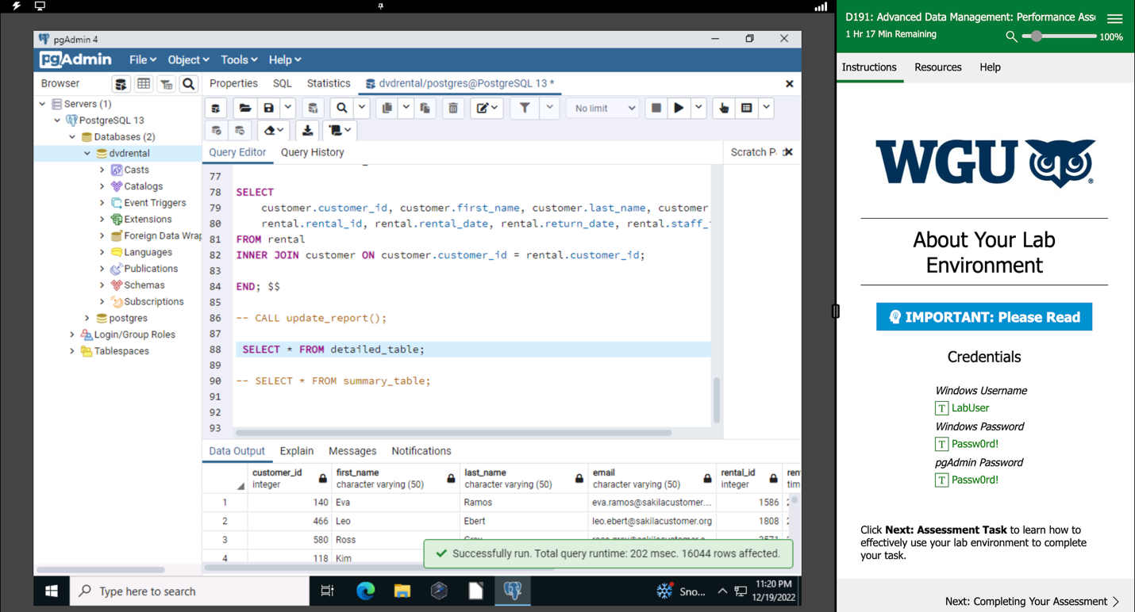

SQL code selecting from the detailed_table

SQL code of the summary_table after the update_report() procedure being called

**Pre-Assessment Video Recording**

I have provided a link to my demonstration video using Panopto showing the functionality of my code and a summary of the programming environment used.

<https://wgu.hosted.panopto.com/Panopto/Pages/Viewer.aspx?id=7c3fd9e9-6d79-4fdf-a348-af7401604d17>

**Sources**

PostgreSQL Tutorial. (n.d). PostgreSQL sample Database.

[https://srm--c.na127.content.force.com/servlet/servlet.FileDownload?retURL=https%3A%2F%2Fsrm--c.na127.visual.force.com%2Fapex%2FFDP%2FCommonsExpandedChatter%3Fcode%3DD191&file=00P3x00001of1JfEAI&_CONFIRMATIONTOKEN=VmpFPSxNakF5TWkweE1pMHlPRlF4TmpvME5Ub3hNQ](https://srm--c.na127.content.force.com/servlet/servlet.FileDownload?retURL=https%3A%2F%2Fsrm--c.na127.visual.force.com%2Fapex%2FFDP%2FCommonsExpandedChatter%3Fcode%3DD191&file=00P3x00001of1JfEAI&_CONFIRMATIONTOKEN=VmpFPSxNakF5TWkweE1pMHlPRlF4TmpvME5Ub3hNQzR3TWpGYSx4WHVzUFFrY3VhYnJsYjAxbHpUd1d6LFlUQmhOamht&common.udd.actions.ActionsUtilORIG_URI=%2Fservlet%2Fservlet.FileDownload)

No other external web sources were used to obtain data or segments of code.